Title: Addressing Capability Gaps in the S-100 Portrayal Model

S-100 Maintenance - Change Proposal Form

|  |  |  |  |
| --- | --- | --- | --- |
| **Organisation** | NIWC | **Date** | 1/16/2020 |
| **Contact** | David Grant | **Email** | S100Viewer@navy.mil |

Change Proposal Type *(Select only one option)*

|  |  |  |
| --- | --- | --- |
| 1.Clarification | 2.Correction | 3.Extension |
|  |  | X |

Location (*Identify all change proposal locations)*

|  |  |  |  |
| --- | --- | --- | --- |
| S-100 Version No. | Part No. | Section No. | Proposal Summary |
| 4.0.0 | 9 | Throughout | Closes gaps in part 9 |
| 9a | Throughout | Closes gaps in part 9a |

Change Proposal

See accompanying redlines for part 9/9a. Fig. 9-10 UML changes highlighted:

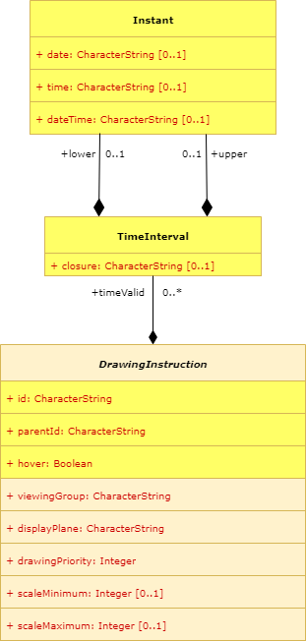

Instant constrained

To: date, time or dateTime

Change Proposal Justification

See TSM7-5.4 Addressing Capability Gaps in the S-100 Portrayal Model.

Adds support for S-52 hover-over, Date Dependent Symbology, and Dependent Symbol Visibility (labels and highlights – e.g. text and SY(INFORM01 / CHDATD01))

What parts of the S-100 Infrastructure will this proposal affect?

S-100 Feature Concept Dictionary Interface or Database

S-100 Portrayal Register

S-100 Feature Catalogue Builder

S-100 Portrayal Catalogue Builder

S-100 UML Models

S-100 GitHub Schemas

**Please send completed forms and supporting documentation to the secretary S-100WG.**